## **Scheduled De-Identification of a FhirStore**

### **Purpose**

This document provides step-by-step instructions for programmatically de-identifying a single FhirStore and posting the de-identified results to a different FhirStore. Specifically a FhirStore will be de-identified at 8:00 pm Eastern Time and uses a De-Identification template created programmatically.

### **Requirements**

### Permissions: Access to google cloud storage, pubsub messaging, compute engine, and fhirstore

Credentials to programmatically use the GCP

### **Procedure**

#### **Step 1: Create a PubSub Topic In GCP and Create a Subscription to the Topic**

1. Create a PubSub Topic with some name
   1. Under Pub/Sub Topics in GCP
2. Create a PubSub Subscription to that Topic
   1. Under Pub/Sub Subscriptions in GCP

#### **Step 2: Create a Cron Job that Will Trigger the PubSub Topic**

1. Go To Cloud Scheduler in GCP
2. For the Frequency of the job to be at 8:00 pm
   1. Set the time zone
   2. Frequency code: 0 20 * * *
      1. Which means everyday at 8:00 pm in the time zone indicated
3. Under Configure Execution, choose target type as pub sub and select the topic created in the previous step

#### **Step 3: Install and Import the Necessary Libraries**

pip install google-cloud-pubsub

pip install google-auth google-auth-oauthlib google-auth-httplib2

pip install google-cloud-dlp

pip install google-api-python-client

pip install google-cloud-storage

imports for libraries used

#### **Step 4: Initialize the PubSub Client**

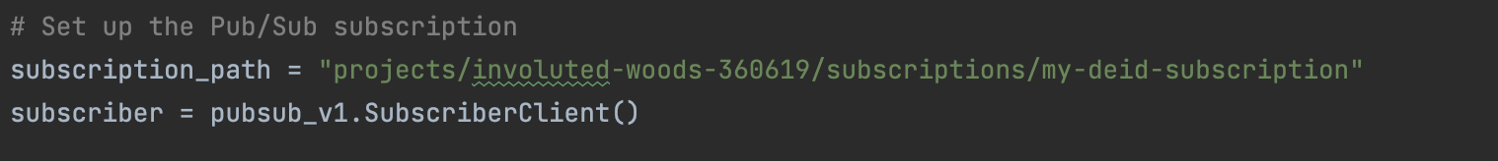

#### **Step 5: Create a Python Function that will be used for De-Identification**

1. Load Credentials and Details to the FhirStore

1. Next step is to set up the de-identification client
   1. Set up the dlp_v2 client which will be used to de-identify data
   2. Look at the GCP DLP tab to figure out which deIdentifcation Template id corresponds to the one needed to de-identify the data

**Step 5:** **Create a File Called Resources that will Have a List of All the Resources In a FhirStore**

1. Each entry in the file should have a name on its own line being delimited by an “enter” after each resource name

**Step 6: Load all the Entries from the Resource File**

1. Loop through all the entries and add it to a list

**Step 7: Create a loop that will de-identify each resource if there are entries to de-identify.**

1. Loops through all the resources in the file resources that was created
   1. Sets the resource path to get 50 entries from that resource page in the fhirStore
      1. Note: later reset the resource path to get the next page of data if data exists there

1. Load the data in the resource path and check if there’s data that needs de-identifying

1. Loop through each entry and have a parameter to scan for those elements in the data

1. Convert the data into a usable format, de-identify it with the parameters previously created

1. Format the data so that it can be imported into a google cloud storage and then a fhirStore

1. Create a storage client to post the data to in a cloud storage bucket. Use the counter to have a unique name for each entry. Need a sleep because of the API request requirements.
   1. Assumes a cloud storage exists with this name already

1. Once all the entries on a page of a resource have been processed change the path to the next page of the same resource and check if there’s data there to process. Otherwise move on to the next resource to process and continue until all of them are done.

1. Once all the data have been posted to the google cloud storage, import the data to a hardcoded fhirStore end point.
   1. Assumes the destination fhirStore already exists
   2. Have the content structure to be RESOURCE

**Step 8: Create a function that will be used to listen for a PubSub message on the Subscription and Handle the Message**

1. The function prints a message that was received from the PubSub.
2. Calls the de-identification() function to run when a pubsub message is received

**Step 9: Create a Loop that Keeps Listening for a PubSub Message from the Subscription Endpoint Set Earlier**

1. Have a method to handle the message once received (callback function created in the previous step)
2. Has a way to exit through user interruption
3. Displays an error message when an error occurs trying to process data

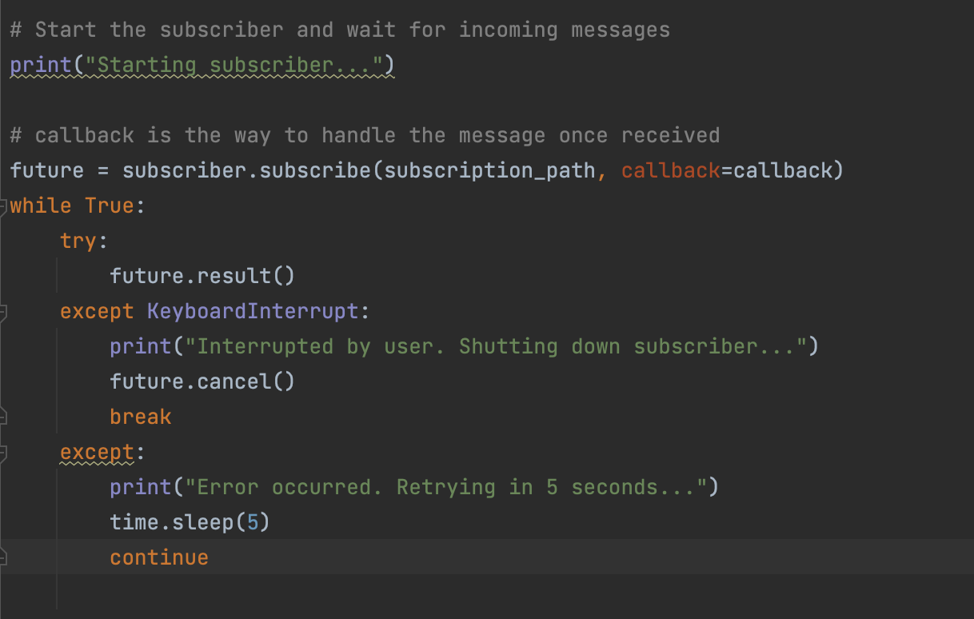

**Step 10: Create a Google Compute Engine so that the Script can Run in the Background and Start De-Identifying Once a Message has Been Received**

1. Go to Google Compute Engine and Create a e2-small instance

The Specifications of the Instance are as follows:

1. Update the Instance with
   1. sudo apt-get update && sudo apt-get upgrade -y
2. Install Python Pip on the Server
   1. sudo apt install python3-pip
   2. check if it was installed correctly with pip3 –version
   3. Install all the libraries on this machine using **Step 3**
   4. sudo apt-get install tmux
      1. used to run a session in the background even when terminal session is closed
3. Can set variable for google application credential with
   1. GOOGLE_APPLICATION_CREDENTIALS=involuted-woods-360619-59d8e0b17cdb.json
      1. Test with echo $GOOGLE_APPLICATION_CREDENTIALS
         1. Should equal path to credential file
4. Upload all the files used for De-Identification into the instance
   1. Resources.txt
   2. De-identification script built
   3. Secret key file
5. tmux new -s my-session -d # to create a background session
6. tmux ls # lists all the sessions
7. tmux attach -t my-session # go to that session
8. Ctrl-b then click d to go back to the terminal
9. Execute step 7 to go to the session and run the script with:
   1. python3 script_name.py
   2. The script should be running and you can exit the terminal with step 9
   3. To test if its working can force run the pub sub scheduler set up earlier
      1. Go back to the session and see if the message was printed and de-identification started
      2. Due to the way it was created the task takes a long time to de-identify a large dataset
10. Don’t stop the instance when done otherwise it won’t continue running in the background

**Conclusion:**

Created a script that runs in the background of a Google Compute Engine that is able to de-identify an entire fhirStore based on a schedule and update it into another fhirStore in a systematic update daily.